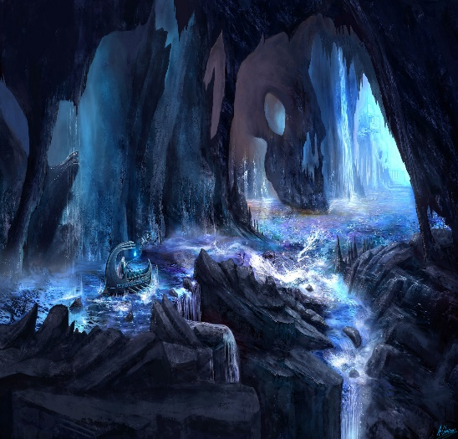Persephone and The Underworld

Persephone woke up with a jolt. She yawned, before focusing on the dark, murky area, embracing her with its musty odour. Persephone slowly got to her feet and looked down at her shoes. They had broken soles sagging downwards and losing its comfortable feel. Her delicate dress, made from fish skin, had been torn into rags.

Looking upwards at Earth, green as usual , Persephone burst into tears. They rolled down her cheeks and onto her rags. To think that humanity, enjoying themselves, gossiping animatedly, didn’t have a care in the world about her. Why, out of all the people dwelling on Earth, did it have to be me? she thought. The echoes of laughter of innocent children rang across the cavern, forcing out even more of Persephone’s tears.

“My child, need not cry, for you can be just as happy here as on Planet Earth,” a man’s voice simpered, or rather, similar to a man. A pale, crooked hand gripped Persephone’s shoulder.

“Uncle Hades?” Persephone asked uncertainly.

“Do not call me Uncle. Your father and I hated each other.” Hades snapped.

“Why?” Persephone wailed in despair, “Why take me away to your horrid Underworld? Let me out, you envious creature, out, I say!” And she made to run towards Hades, to give him severe injuries and pain. But Hades, using his mighty powers, repelled her backwards.

“Run away back to Earth and I will kill you!” Hades drew closer.

“Here, you can have a better life, a life which is worth living, a life which we can spend more time together. I don’t perceive Demeter or *Zeus* spending time with you. They’re too overindulged in their work.”

“Let me out!” Persephone yelled angrily.

“Stay here, where there is better quality of product.”

“Let me out!”

“Stay here, where you can make better friends than the hateful humanity.”

“Let me out!”

“Stay here, where you can gain more intelligence than your ignorant parents.”

“Let me out!”

Hades sighed. “Well, then. To return to Earth, you must eat seven pomegranate seeds.”

That being said, large pomegranate trees grew on either side of the caverns.

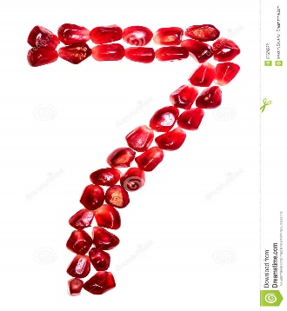

Using his powers, Hades took out seven seeds from a pomegranate, leaving the fruit in one piece. He gave them to Persephone, whose face read uncertainty.

“I have not poisoned a single seed.” Hades whispered, “Now, eat.”

Persephone ate. For a brief moment, nothing happened. Then, Persephone’s appearance had changed. From head to toes, she became translucent and pearly-white.

“You foolish girl. Did you really think I would let you go?” The people of the Underworld approached, forming a ring around Persephone.

Hades cackled evilly. “You are one of us, now.”

